**Chandpur Science and Technology University**



## Department of Computer Science and Engineering

**LAB ASSIGNMENT #5**

**C Lab Assignment Submitted By:**

**Name: Iftekhar Hossain**

**Student ID: B220101024**

**Submitted To:**

**Prince Mahmud**

**Lecturer**

**Department of Computer Science and Engineering, CSTU**

Marks & Signature

|  |
| --- |
|  |

Lab Date:

Submission Date: 15/12/2023

**Problem No – 1**

**Title:**

Write a program to find the maximum, minimum and average from a list of floating point numbers.

**Code and Output:**

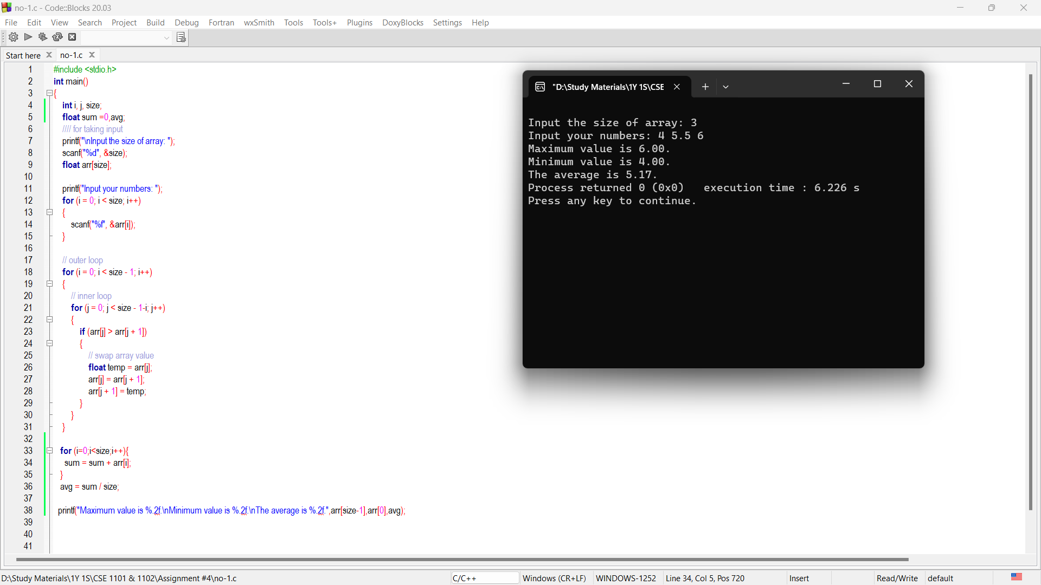

**Problem No – 2**

**Title:**

Write a program to delete duplicate elements from an array.

**Code and Output:**

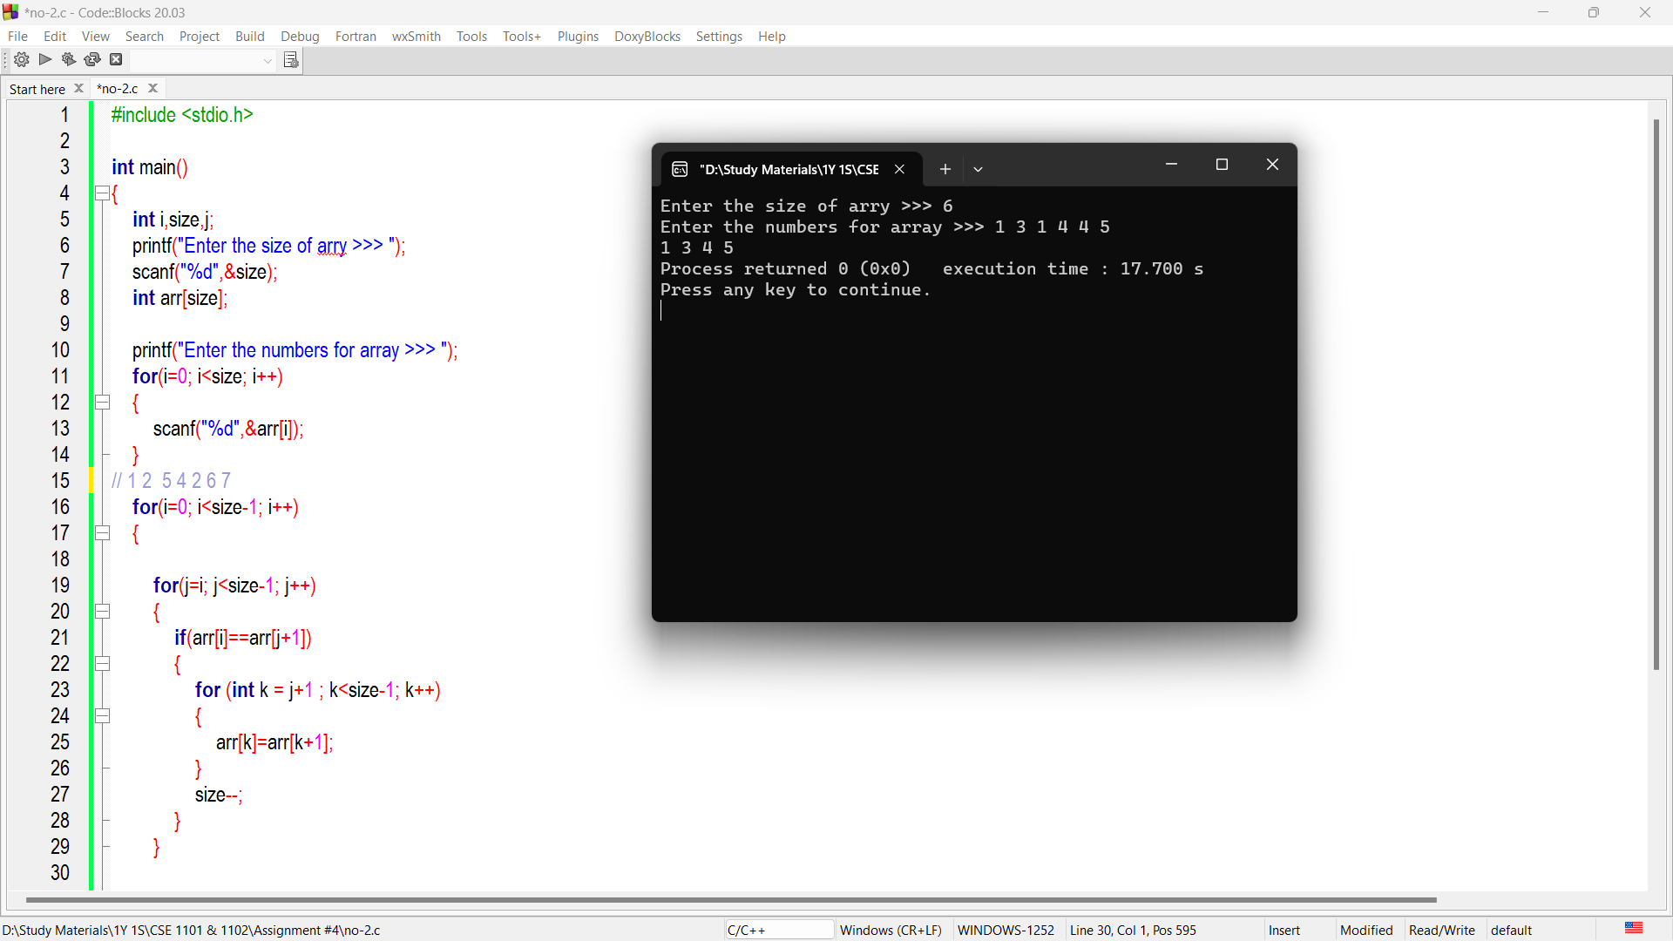

**Problem No – 3**

**Title:**

Write a program to merge two sorted arrays.

**Code and Output:**

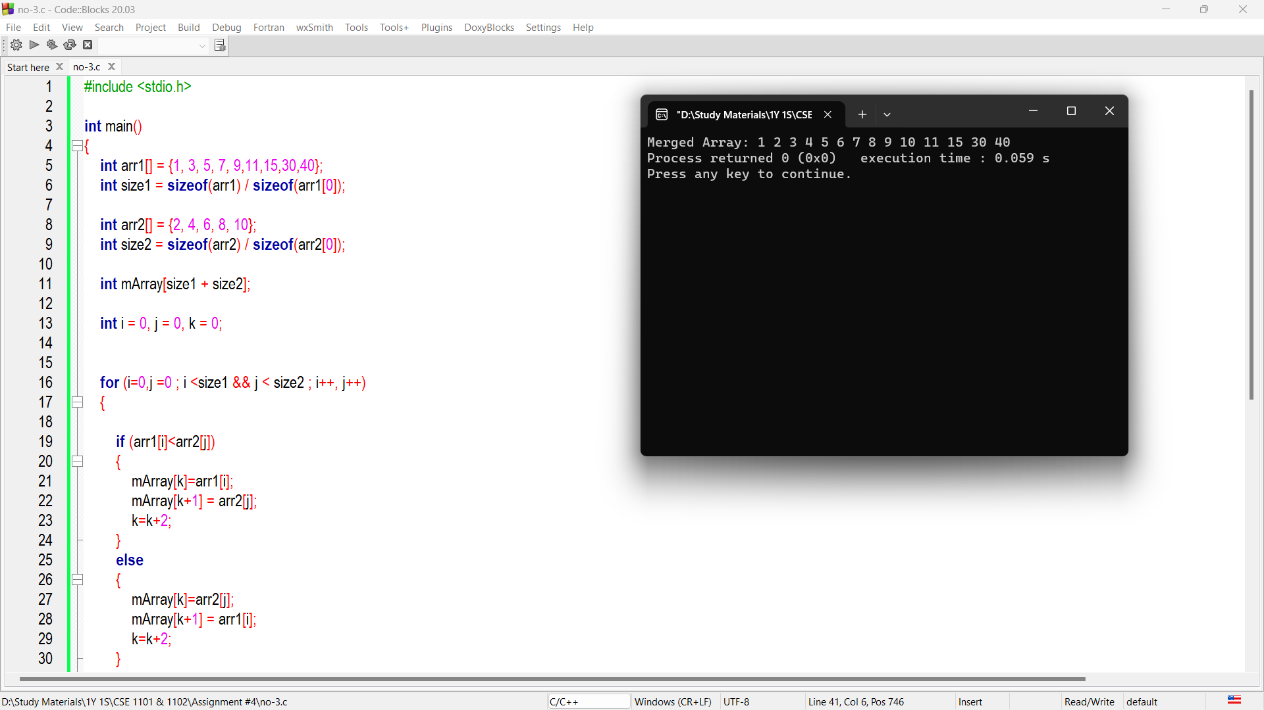

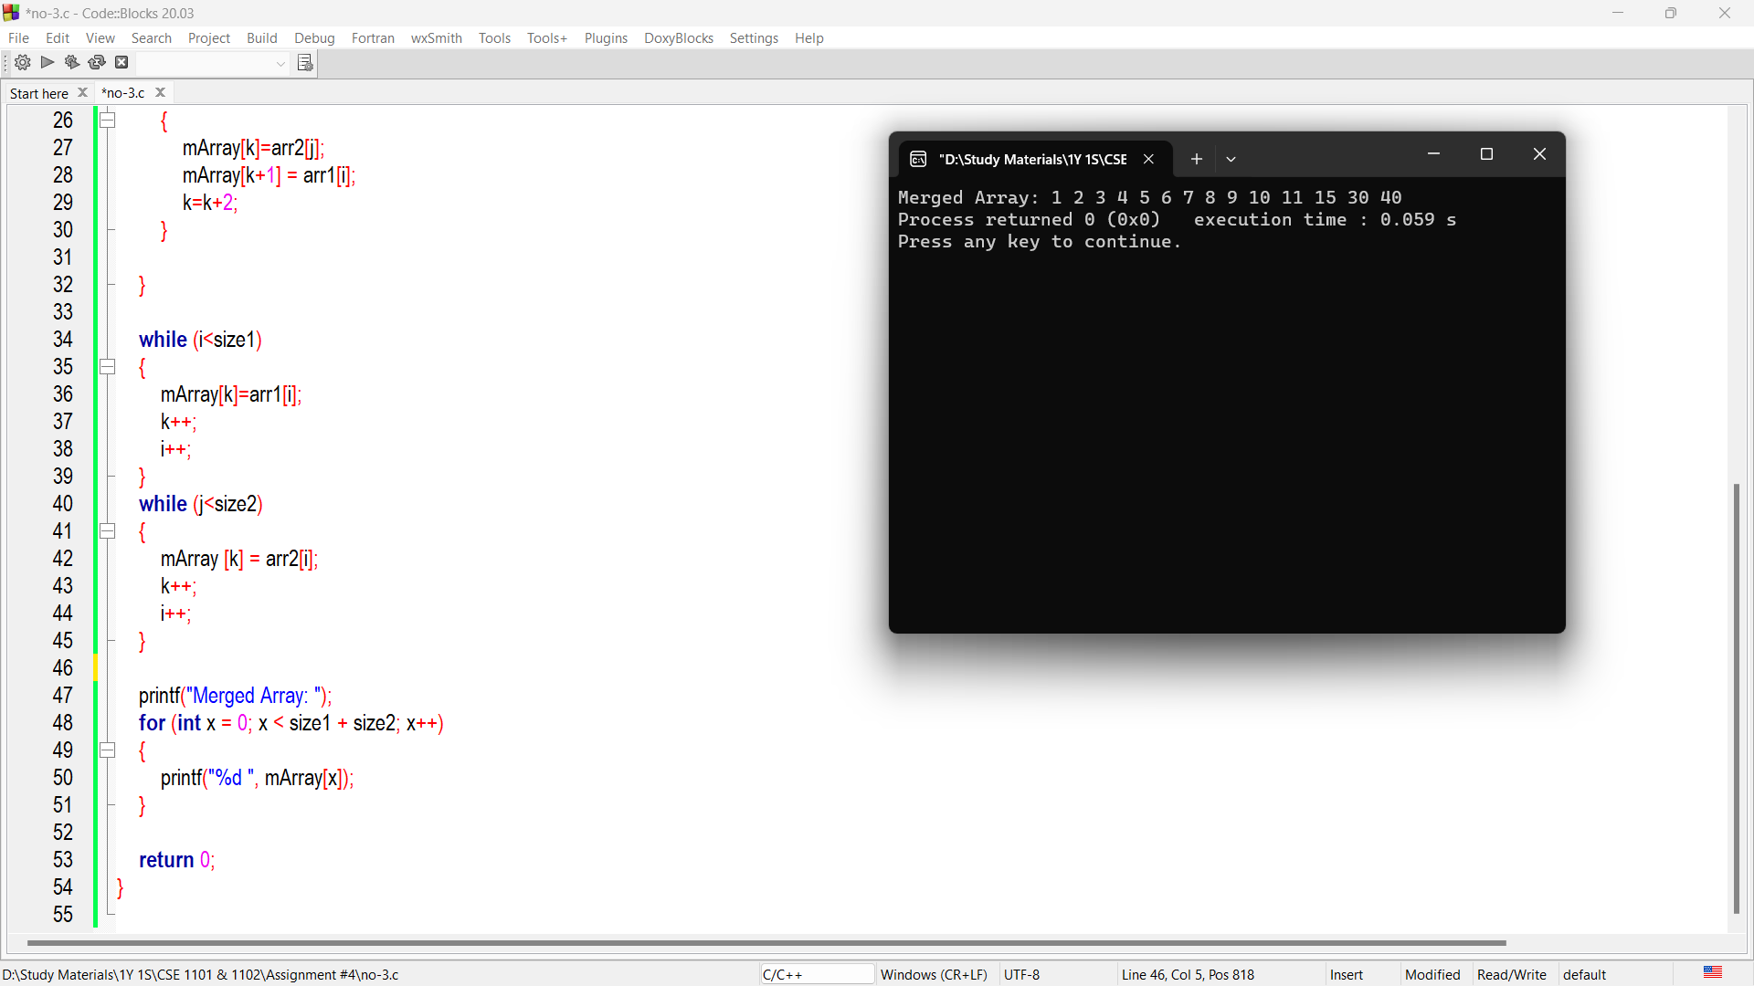

**Problem No – 4**

**Title:**

Write a program to read two matrixes from user into two different 2D array and multiply these two matrixes and finally display the result.

**Code and Output:**

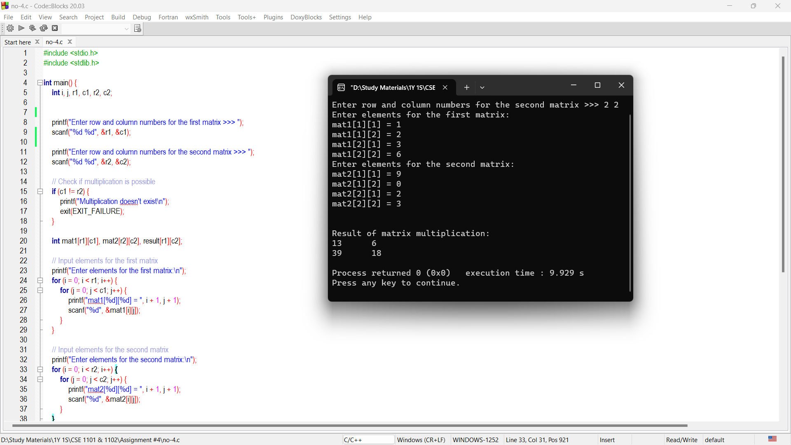

**Problem No – 5**

**Title:**

Write a program to display the numbers divisible by 4 or 7 from a 2D array of integers and find the sum of those numbers as well.

**Code and Output:**

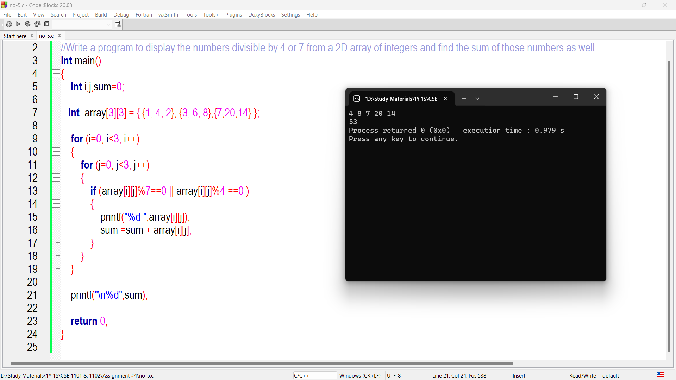

**Problem No – 6**

**Title:**

Write a program insert an Element Desired or Specific Position in an Array.

**Code and Output:**

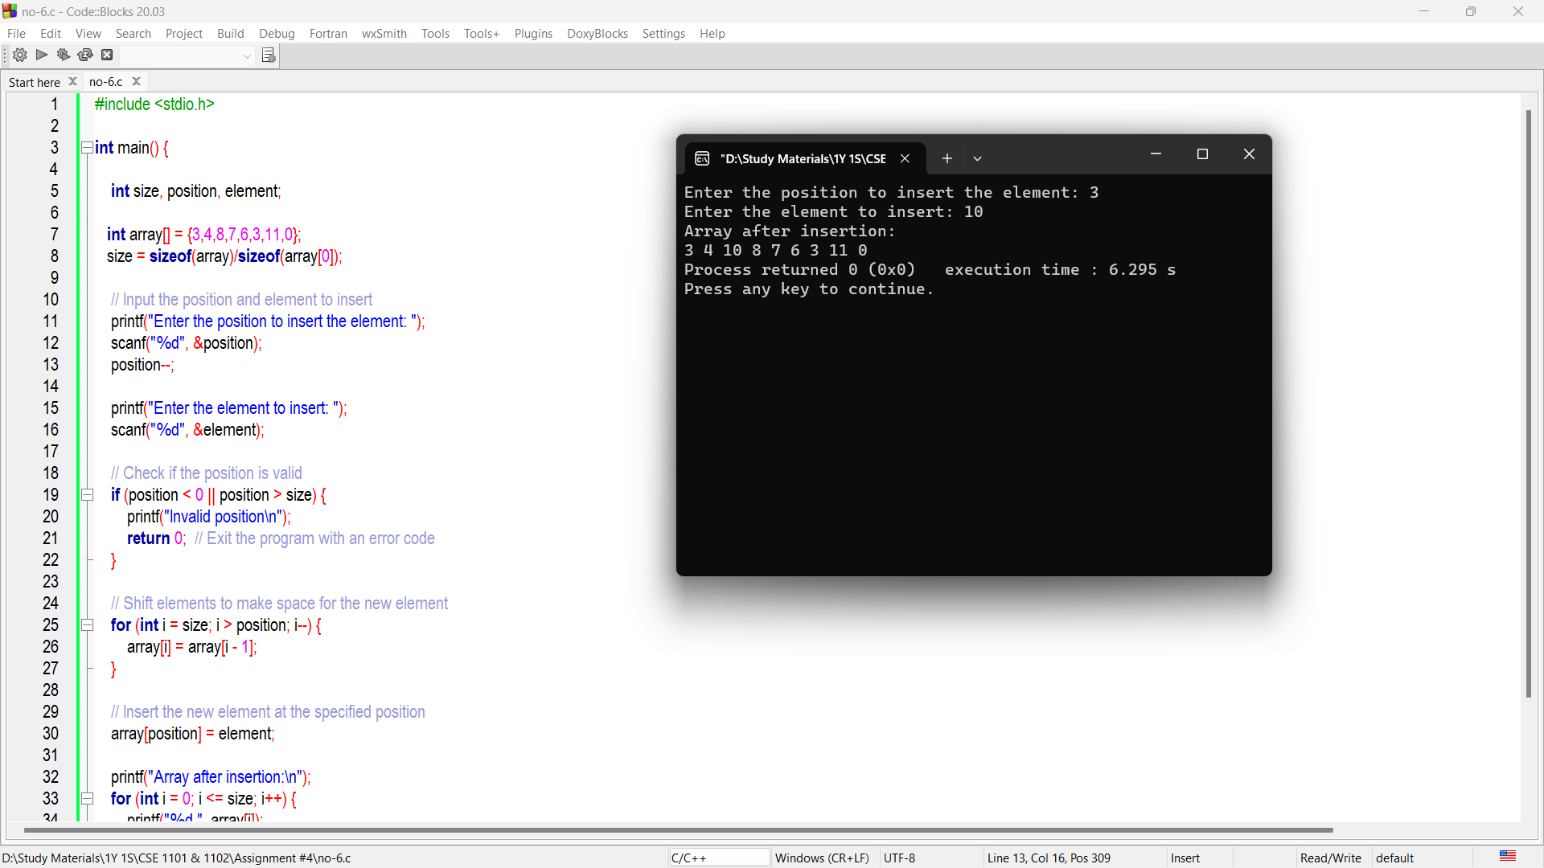

**Problem No – 7**

**Title:**

Write a program delete Element from an Array at a Desired or Specific Position.

**Code and Output:**

